

MECH4880

Refrigeration and Air Conditioning

**Assignment 1 Part A**

Name: Hengcheng Zhang

Number: z5130844

# Executive Summary

This project is to estimate the heat load of two rooms in a two storey retail complex. The project information is given in the specification. Design day is selected to be December 22nd in summer and June 21st in winter since they are the summer and winter solstice.

External load calculation is performed in chapter 3. In order to get that, wall specification must be carried out firstly. Resistance coefficient of ceiling, floor, external wall and internal wall are found out and calculated according to tables in chapter 5 of DA09. In order to fulfil the minimum R-value requirement of BCA, a correction process is executed. The corrected R-value and U-values are listed in the following table.

|  |  |  |  |  |
| --- | --- | --- | --- | --- |
| **Surfaces** | | **Uncorrected**  **R-values** | **Corrected R-values** | **Corrected U-values** |
| Floor | | 0.725 | 1.725 | 0.580 |
| Ceiling | T.0.6 | 2.496 | 3.496 | 0.286 |
| MM.0.3 | 0.588 | 3.588 | 0.279 |
| External Wall | | W: 0.5055 | 2.5055 | 0.399 |
| S: 0.5085 | 2.5085 | 0.399 |
| Internal Wall | | 0.562 | 1.062 | 0.942 |

Based on the selected materials, the mass of roofs, floors and walls are computed. Then it is able to get the storage load factor.

SFT06 = 308 kg/m2, SFMM03 = 575.7 kg/m2

After determining the Equivalent temperature difference, the solar transmission loads from walls and windows in both summer and winter are carried out. Since there is no temperature difference between rooms in the shopping complex, the partition load is zero. The total external loads are found, which is listed below.

|  |  |  |
| --- | --- | --- |
| **Heat Load for External Surface** | | |
| **Room** | **Summer(W)** | **Winter(W)** |
| T.0.6 | 909 | 1295 |
| MM.0.3 | 5951 | 8890 |

Internal loads are divided into four parts: people, equipment, lights and infiltration. Computing according to chapter 7 in DA09, the internal loads of the two rooms in summer and winter are found.

|  |  |  |  |  |
| --- | --- | --- | --- | --- |
| **Internal Load** | | | | |
| Division | T.0.6 | | MM.0.3 | |
| Sensible(W) | Latent(W) | Sensible(W) | Latent(W) |
| Summer | 15313 | 6238 | 42576 | 16709 |
| Winter | 8375 | 9383 | 20129 | 23164 |

At last, the findings are summarized and psychrometric charts for both rooms are drawn. A CAMEL simulation is performed to verify our hand calculation result. The differences are acceptable. The results are listed below.

|  |  |  |  |  |  |
| --- | --- | --- | --- | --- | --- |
| **Season** | **Rooms** | **Load** | **CAMEL** | **HAND** | **Difference** |
| Summer | T06 | sensible | 16471 | 16222 | 1.50% |
| latent | 6741 | 6238 | 7.50% |
| MM03 | sensible | 53805 | 48528 | 4.90% |
| latent | 17950 | 16709 | 6.90% |
| winter | T06 | sensible | 10296 | 9670 | 6.10% |
| latent | / | 9383 | / |
| MM03 | sensible | 30850 | 29019 | 5.90% |
| latent | / | 23164 | / |

Contents

Executive Summary 2

1. Introduction 6

2. Design Day Selection and Specification Comprehension 7

2.1 Design Day Selection 7

2.2 Design Conditions 7

2.3 Ceiling Space 8

2.4 Definition of Terminologies 8

2.5 Temperature range 8

3. External Loads 9

3.1 Wall Specifications 9

3.1.1 Floor (T.0.6 & MM.0.3) 9

3.1.2 Ceiling 9

3.1.3 External Wall 11

3.1.4 Internal Wall 12

3.1.5 Correction 13

3.1.6 Calculation of Storage Mass 14

3.2 Solar transmission 17

3.2.1 Summer 18

3.2.2 Winter 20

3.2.3 Summary of heat load for External surfaces 20

3.3 External Loads of Partitions 20

4. Internal Loads 21

4.1 Internal Loads in Summer 21

4.1.1 People 21

4.1.2 Appliances and Equipment 21

4.1.3 Lighting 22

4.1.4 Infiltration 23

4.2 Internal Loads in Winter 24

4.2.1 People 24

4.2.2 Appliances and Equipment 24

4.2.3 Lighting 24

4.2.4 Infiltration 24

4.3 Internal Loads in Summary 25

5. Load Summary and Psychrometric Charts 25

5.1 Load Table 26

5.2 Psychrometric Charts 26

5.2.1 Room T.0.6 26

5.2.2 Room MM.0.3 28

6. CAMEL simulation 30

6.1 Simulation Process 30

6.2 CAMEL Results and Comparing 32

7. Conclusion 33

References 34

Appendix A 35

# 1. Introduction

The aim of this report is to estimate the heating and cooling load for shops in a two storey retail complex in order to design the HVAC system. A detailed calculation is performed to T.0.6 and MM.0.3 for both summer and winter. In addition, a CAMEL simulation is also performed on these two rooms for verification.

The building located in Temperate Town of capital territory, which is at 30° South latitude, climate zone 6. The building has two floors and the layout of first floor is shown in figure 1. The target rooms are Usual Shirts and JB Low-Fi.

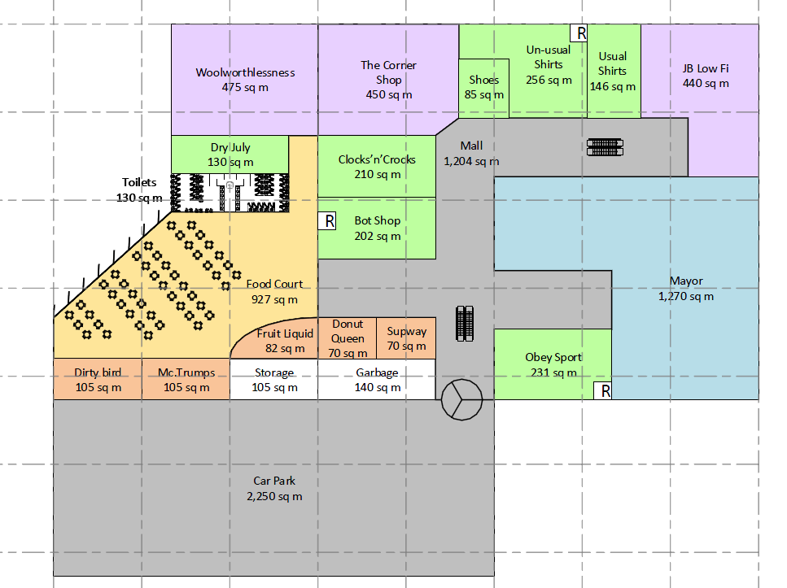

*Figure 1: Building Layout*

Assumptions are made during this project.

1. The hottest time in a year is 22nd December, while the coldest day is 21st June.
2. 3pm is peak hour. Most customer and equipment loads are seen at this time.
3. The thickness of thin marble is assumed to be 20mm.
4. Steel sash window is utilized, and k1 = 1.1.
5. Haze correction factor k2 is 1 since there is no haze in Australia.
6. The location is at 15 m elevation and the altitude correction factor is 1.
7. Windows are gasketed.
8. The shopping centre opens at 9 am and closed at 8pm.
9. Air pressure is fixed at 101kPa

Other assumptions are made when they are needed in the following section.

# 2. Design Day Selection and Specification Comprehension

## 2.1 Design Day Selection

A design day is defined as a day of outside and inside design conditions, when there is no haze in the air to reduce the solar heat and when all of the internal loads are normal. [1] It is selected to be the most severe days in a year in order to make sure the HVAC system is able to provide comfortable room conditions for the whole year. There are two aspects for the working condition, external loads and internal loads. Then it is simplified as the selection of the hottest day in summer and the coldest day in winter.

For our target, which is a shopping centre in southern hemisphere, the hottest day in summer is December 22nd in theory, which is the summer solstice, while the coldest day is the winter solstice, which is June 21st.

7 am is chosen as the coldest time in a day according to Table 14 in DA09, which specifies that the heat gain in 7am in June 21 is zero. According to Occupancy and Operation Profiles of a Class 6 Shop or Shopping Centre in NCC 2016[2], no customer is in the shopping centre at 7am, and leads to the lowest internal load.

According to Table 2 in DA09, which shows the correction of outdoor design temperature for time of a day, the hottest time in a day is 3pm. The quantity of people is also at its peak then.

## 2.2 Design Conditions

Seen from the specification provided for the task, the external condition for summer is 33.8°C DB, 22.9°C WB, and it is 2.1°C DB, 80%RH for winter. Inserting this information to CAMEL, it is able to get the yearly and daily temperature range, which is shown in Figure1.

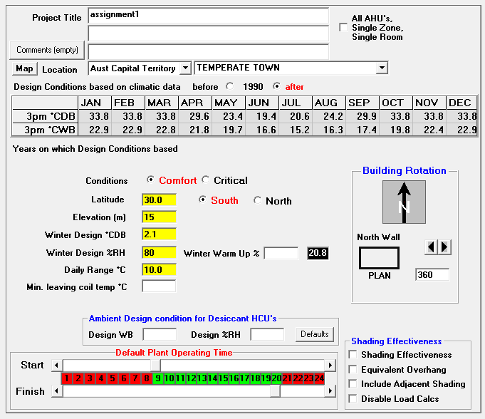

*Figure 2: Temperature Range from CAMEL*

The yearly range is calculated as:

The external condition need to be corrected according to Table 3 in DA09, which is shown in Table 1 below for this correction.

*Table 1: Corrections in Outdoor Design Conditions for Time of Year*

|  |  |  |  |  |  |  |  |  |  |  |
| --- | --- | --- | --- | --- | --- | --- | --- | --- | --- | --- |
| Yearly Range | Dry or Wet Bulb | Jan | Feb | Mar | Apr | May | Sep | Oct | Nov | Dec |
| 32°C | Dry-Bulb | 0 | 0 | -1 | -3 | -6 | -4 | -4 | -2 | 0 |
| Wet-Bulb | 0 | 0 | 0 | -1 | -2 | -2 | -2 | 0 | 0 |

As seen from the table the corrections for both dry-bulb and wet-bulb are zero in December.

Corrections for time of the day should also be carried out according to Table 2 in DA09. When the daily temperature range is 10°C, It is seen that the corrections for dry-bulb and wet-bulb are both zero in 3pm.

The design conditions are determined then, and shown in the following table.

*Table 2: Design Conditions*

|  |  |  |  |
| --- | --- | --- | --- |
| **Design condition** | **External conditions** | **Internal conditions** | |
| **T.0.6** | **MM.0.3** |
| **Summer** | 33.8°C DB/22.9°C WB | 23.5°C DB/55%RH | 23.5°C DB/55%RH |
| **Winter** | 2.1°C DB/80%RH | 21°C DB/80%RH | 21°C DB/80%RH |

## 2.3 Ceiling Space

The ceiling space is the space between the ceiling and the above floor. The ventilation piles and other equipment are arranged in this area.

According to the specification, the ceiling space is:

The equipment in the ceiling space is not given, thus is not taken into calculation in this project.

## 2.4 Definition of Terminologies

Some terms such as storage mass, AHU, glazing and partition are significant to be understand before calculating the heat load.

Storage mass is a term of the heat storage effect, which is the effect that part of the instantaneous heat is absorbed by solid surfaces, and to be released later. The heat storage capacity is proportional to the mass of the mass of material.

AHU is a system used to regulate air as part of the HVAC system.

Glazing is the glass part of windows and walls.

Partition is the internal wall between two rooms.

## 2.5 Temperature range

Based on the discussion in the former part and the calculation in CAMEL shown in figure 1, it is obvious that the yearly temperature range is 31.7°C and the daily range is 10°C.

# 3. External Loads

## 3.1 Wall Specifications

U value or transmission coefficient is the rate of heat transferred through a building structure. [1] While R value is the thermal resistance coefficient and it is the inverse of U value.

It takes the following steps to calculate the U value:

* Determine the resistance of each component and air surface;
* Add the resistances together;
* Take the reciprocal. U = 1/R [1]

It should be note that the outdoor wind speed would affect the external thin air film coefficient and thus U value. While for the internal side of the walls, the air film is assumed to be still.

### 3.1.1 Floor (T.0.6 & MM.0.3)

The floor for the two rooms is the same, which is 100mm concrete and 25mm sand/topping with carpet and underlay.

The transmission coefficient for this kind of floor is listed in Table 27 in DA09, which is calculated based on the related resistance listed in Table 37 in DA09. This saved our calculation effort.

*Table 3: Transmission Coefficient of Floor (Heat Flow up)*

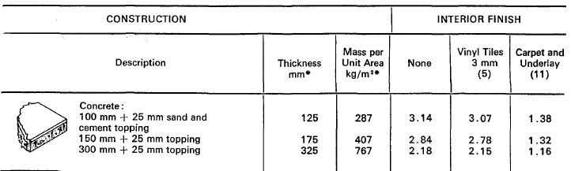

As seen from Table 3 above, the U value for floor in these two rooms is 1.38 W/m2°C.

### 3.1.2 Ceiling

For MM.0.3, the ceiling construction is given as bituminous felt roof with 150mm of concrete and 25mm of sand and cements topping and plaster tiles. According to Table33 in DA09, its U values for summer and winter are 1.70 m2°C/W. The corresponding R values are 0.588.

For shop T.0.6, the ceiling structure is shown below.

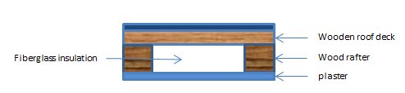

*Figure 2: Ceiling structure of T.0.6*

The resistance of each ceiling layer is listed in Table 4. The total resistance is calculated as:



*Figure 3: Wood rafter with fiberglass insulation structure*

The wood rafter structure is shown below according to AS 1684 2010[3]. Calculating from the structure, area of insulation is 3.12 m2, area of wood rafter is 0.39 m2 and the total area is 3.51 m2. The parallel resistance is then:

The total resistance is:

The U-value:

*Table 4: Resistance properties of ceiling layers*

|  |  |  |  |
| --- | --- | --- | --- |
| **Component** | **Thickness (mm)** | **R-values (m^2℃/W )** | **References** |
| Metal deck | 30 | 0 | Table37 Page81 DA09 |
| Wood deck | 25 | 0.165 | Table37 Page82 DA09 |
| Wood rafter | 100 | 0.722 | Table37 Page82 DA09 |
| Fiberglass | 100 | 3.15 | Table37 Page79 DA09 |
| Plaster | 15 | 0.041 | Table37 Page78 DA09 |

### 3.1.3 External Wall

As given in the specification, the external wall of shop T.0.6 is 2×90mm brick with 60mm air gap + 15mm gypsum plaster + thin marble, while that for MM.0.3 is the same without the marble. Their structures are illustrated below.

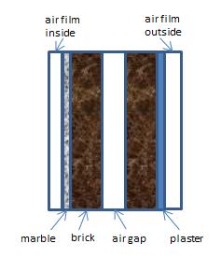 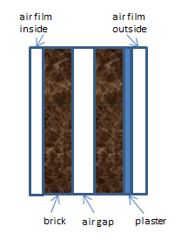

*Shop T.0.6 MM.0.3*

*Figure 4: External Wall Structure*

As seen from Table 4, which is from Table 24 in DA09, the U value for 2×90mm brick with 60mm air gap + 15mm gypsum plaster is 2.02 in winter and 2.01 W/m2°C in summer. The difference is caused by different external wind speed as discussed in chapter 3.1. Taking their reciprocal, the correlated R values are 0.495 and 0.498 m2°C /W respectively. These are the R values for external wall of MM.0.3.

*Table 5: Transmission Coefficient of External Wall*

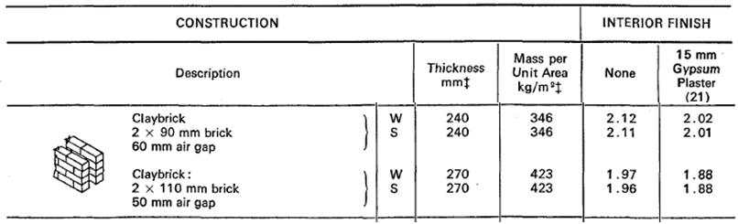

As to shop T.0.6, the thickness of the thin marble is assumed as 15mm. According to Table 37 (p 79) in DA09, its resistivity is 0.77-0.6 m. °C/W. Take 0.7 into calculation, the R value for the thin marble is:

The external wall resistances for shop T.0.6 are calculated as:

The U-value is:

### 3.1.4 Internal Wall

The structure of internal wall is shown below in figure 4. It is 12mm plaster board with 100mm air gap.

As seen in Table 26 in DA09, the transmission coefficient for partition of 12 mm plasterboard with 100 mm air inside and still air film on both sides is 1.78 W/m2°C. The chart is shown below in Table 5.

*Table 5: Transmission Coefficient of Internal Wall*

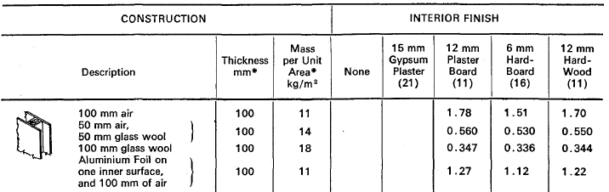

In summary, the U values for shops T.0.6 and MM.0.3 are listed below.

*Table 6: R value and U value for all surfaces*

|  |  |  |  |
| --- | --- | --- | --- |
| **Surfaces** | | **R-value(m^2°C/W)** | **U-value(W/m^2°C)** |
| Floor | | 0.725 | 1.38 |
| Ceiling | T.0.6 | 2.496 | 0.401 |
| MM.0.3 | 0.588 | 1.7 |
| External Wall | | W: 0.5055 | W: 1.978 |
| S: 0.5085 | S: 1.967 |
| Internal Wall | | 0.562 | 1.78 |

### 3.1.5 Correction

To save energy efficiency, BCA provide a minimum R-value for each structure. According to NCC, Table J1.6, the minimum R-value requirement of floor is 1.25 m2°C /W. As seen from Table 5, the R-value for floors of these two rooms is 0.725 m2°C /W. Two piece of insulations whose R-value equals 0.5 are needed to fulfil the minimum requirement. The corrected R-value is 1.725 m2°C /W.

*Table 7: Minimum R-value Requirement of Floor*

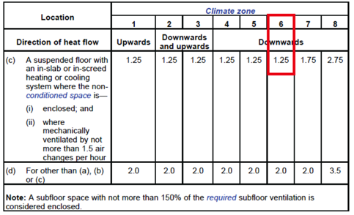

As shown in Table 6, the minimum R-value requirement of the ceiling in zone 6 is 3.2 m2°C /W. As calculated in the former part, which is also shown in Table 5, the R-value of T.0.6 ceiling is 2.496. The R-value of MM.0.3 ceiling is 0.588. They are all smaller than the requirement. In this case, insulations with R-value of 0.5 need to be added. For T.0.6, 2 insulations are needed, while for MM.0.3, six insulations are required. Their new R-values are 3.496 and 3.588 m2°C /W respectively.

*Table 8: Minimum R-value Requirement of Ceiling/Roof*



For the external walls. Density is need to be calculated to determine the minimum requirement. The double clay brick structure of this external wall has a density 346 kg/m2. As shown in Table 8, which is a copy of Table J1.5a from NCC 2016 BCA, for a surface density larger than 220 kg/m2, the minimum R-value is 2.3 m2°C /W. So two pieces of insulation are required for the external wall.

*Table 9: Minimum R-value Requirement of External Walls*



Seen from Table J1.5b, the minimum requirement for internal wall is 1 m2°C /W. So 1 piece of insulation is required for of internal wall.

In summary, the correction for all surfaces is listed below in Table 10.

*Table 10: Correction of R-values and U-values*

|  |  |  |  |  |  |
| --- | --- | --- | --- | --- | --- |
| **Surfaces** | | **R-values(m^2°C/W)** | **Increment of Insulation(m^2°C/W)** | **Corrected R-values** | **Corrected U-values** |
| Floor | | 0.725 | 1 | 1.725 | 0.580 |
| Ceiling | T.0.6 | 2.496 | 1 | 3.496 | 0.286 |
| MM.0.3 | 0.588 | 3 | 3.588 | 0.279 |
| External Wall | | W: 0.5055 | 2 | 2.5055 | 0.399 |
| S: 0.5085 | 2 | 2.5085 | 0.399 |
| Internal Wall | | 0.562 | 0.5 | 1.062 | 0.942 |

### 3.1.6 Calculation of Storage Mass

Storage mass for shop T.0.6 and MM.0.3 is calculated below separately.

For shop T.0.6, floor mass is calculated in Table 10. The area of floor is given in the specification.

*Table 11: Storage mass of Floor (T.0.6)*

|  |  |  |  |  |  |
| --- | --- | --- | --- | --- | --- |
| **Component** | **Thickness (mm)** | **Density** | **Mass per unit area (Kg/m2)** | **Area (m2)** | **Mass (kg)** |
| 100mm concrete with + 25mm sand/topping + carpet and underlay | 125 | / | 287 | 146 | 41902 |
| Batts*2 | 150 | 32 | / | 146 | 700.8 |
| Total mass (kg) | | | | | 42602.8 |

The mass of ceiling is calculated in Table 12 below. The area of ceiling is the same with floor.

*Table 12: Storage mass of Ceiling (T.0.6)*

|  |  |  |  |  |  |
| --- | --- | --- | --- | --- | --- |
| **Component** | **Thickness (mm)** | **Density** | **Mass per unit area (Kg/m2)** | **Area (m2)** | **Mass (kg)** |
| Metal deck | 30 | 78.5 | / | 146 | 343.83 |
| Wood deck | 25 | 106 | / | 146 | 386.9 |
| Wood rafter& fiberglass | 100 | 177.89 | / | 146 | 2597.194 |
| Plaster | 15 | 1121 | / | 146 | 2454.99 |
| Batts*2 | 150 | 32 | / | 146 | 700.8 |
| Total mass (kg) | | | | | 6483.714 |

The mass of external wall is calculated and demonstrate in Table 12. Only the north wall of T.0.6 is external wall. It has a length of 9 meters and a 6 meters’ height. There is 3m*3m window on the north wall. So the area of external wall is 45 m2.

*Table 13: Storage mass of External Wall (T.0.6)*

|  |  |  |  |  |  |
| --- | --- | --- | --- | --- | --- |
| **Component** | **Thickness (mm)** | **Density** | **Mass perunit area (Kg/m2)** | **Area (m2)** | **Mass (kg)** |
| 2×90mm brick with 60mm air gap | 240 | / | 346 | 45 | 15570 |
| Plaster | 15 | 1121 | / | 45 | 756.675 |
| Marble | 20 | 2700 | / | 45 | 2430 |
| Batts*4 | 300 | 32 | / | 45 | 432 |
| Total mass (kg) | | | | | 19188.675 |

The internal wall of T.0.6 is the east, west and the south wall. There should be a door on the south wall, but is neglected here for simplification. The length of the internal wall is 2*16+9, which times the height 6 m, gives the area of 246 m2. The surface density could be found in Table 4.

*Table 14: Storage mass of Internal Wall (T.0.6)*

|  |  |  |  |  |  |
| --- | --- | --- | --- | --- | --- |
| **Component** | **Thickness (mm)** | **Density** | **Mass perunit area (Kg/m2)** | **Area (m2)** | **Mass (kg)** |
| 12mm plaster board + 100mm + 12mm plaster board | 124 | / | 11 | 246 | 2706 |

For MM.0.3, the storage mass is calculated in the same way. The calculation of its floor, ceiling, external and internal wall is carried out in Table 14 to Table 17.

The area of floor and ceiling is given in the specification, which is 440 m2. The north and east wall is the external wall, the east, south and the south-east corner walls are the internal wall. Their surface areas are calculated according to the layout in the specification. The window on the north and east wall are subtracted.

*Table 15: Storage mass of Floor (MM.0.3)*

|  |  |  |  |  |  |
| --- | --- | --- | --- | --- | --- |
| **Component** | **Thickness (mm)** | **Density** | **Mass per unit area (Kg/m2)** | **Area (m2)** | **Mass (kg)** |
| 100mm concrete with + 25mm sand/topping + carpet and underlay | 125 | / | 287 | 440 | 126280 |
| Batts*2 | 150 | 32 | / | 440 | 2112 |
| Total mass (kg) | | | | | 128392 |

Storage mass of the ceiling:

*Table 16: Storage mass of Ceiling (MM.0.3)*

|  |  |  |  |  |  |
| --- | --- | --- | --- | --- | --- |
| **Component** | **Thickness (mm)** | **Density** | **Mass per unit area (Kg/m2)** | **Area (m2)** | **Mass (kg)** |
| Bituminous felt roof with 150mm of concrete and 25 mm of sand and cement topping and plaster tiles | 187 | / | 437 | 440 | 192280 |
| Batts*6 | 450 | 32 | / | 440 | 6336 |
| Total mass (kg) | | | | | 198616 |

The storage mass of the external wall:

*Table 17: Storage mass of External Wall (MM.0.3)*

|  |  |  |  |  |  |
| --- | --- | --- | --- | --- | --- |
| **Component** | **Thickness (mm)** | **Density** | **Mass per unit area (Kg/m2)** | **Area (m2)** | **Mass (kg)** |
| 2×90mm brick with 60mm air gap | 240 | / | 346 | 207 | 71622 |
| Plaster | 15 | 1121 | / | 207 | 3480.705 |
| Marble | 20 | 2700 | / | 207 | 11178 |
| Batts*4 | 300 | 32 | / | 207 | 1987.2 |
| Total mass (kg) | | | | | 88267.905 |

The storage mass of the internal wall:

*Table 18: Storage mass of Internal Wall (MM.0.3)*

|  |  |  |  |  |  |
| --- | --- | --- | --- | --- | --- |
| **Component** | **Thickness (mm)** | **Density** | **Mass per unit area (Kg/m2)** | **Area (m2)** | **Mass (kg)** |
| 12mm plaster board + 100mm + 12mm plaster board | 124 | / | 11 | 276 | 3036 |

The storage load factor is calculated based on the former mass information. The mass per unit area of floor is calculated firstly. These two rooms both have external walls, so it is:

For shop T.0.6, it is:

Look into Table 6 of DA09, the storage load factor for the north wall of T.0.6 is 0.54.

For shop MM.0.3, the mass per unit area of floor is:

The storage load factor for of north wall is 0.59. For the east wall of MM.0.3, it is 0.18

## 3.2 Solar transmission

The external walls are exposed to sunlight, which brings the heat gain through solar transmission. For this case, the north wall of shop T.06, MM.03 and the east wall of MM.03 will experience solar transmission load. Since these rooms are on the ground floor, their ceilings and internal walls are not exposed to sunlight.

The solar transmission is separated as conduction and solar radiation. For solar radiation:

Where SF is the storage factor;

k1 is sash correction factor;

k2 is haze correction factor;

k3 is altitude correction factor;

k4 is dew point correction factor;

k5 is glass factor.

The conduction for external surface is calculated as:

Where Q is the total heat flow;

U is the U-value of glazing;

A is the area of glazing;

∆T is the equivalent temperature difference.

### 3.2.1 Summer

For structures, heat flow through it is unsteady, so an equivalent temperature difference is applied in calculation. The equivalent temperature difference represents a combination of the variable solar radiation and outdoor temperature. The usage of equivalent temperature would decrease its heat load in calculation.

In summer, it is calculated as below for medium color wall:

Where:

σs is themaximum solar heat gain of 30° South from Table 14 of DA09;

σm is the maximum solar heat gain of 40° South from Table 14 of DA09;

∆Tem is the equivalent temperature in Table 21 from DA09 for exposed wall and roof;

∆Tes is the equivalent temperature in Table 21 from DA09 for shaded wall and roof

When the daily range is 10 °C, there is no need for correction based on table 21 in DA 09.

Looking for Table 21 and 22 in DA09, the surface density is needed. For T.0.6 and MM.0.3, it is 426 kg/m2. For the north wall, it could be found that for the north wall:

σs = 47 W/m2

σm = 88 W/m2

∆Tem = 12.6 °C

∆Tes = 4.9 °C

For the east wall of MM.03, it is found that:

σs = 44 W/m2

σm = 44 W/m2

∆Tem = 11.9 °C

∆Tes = 4.9 °C

Shop T.0.6 has a north wall of 45 m2, and a 0.399 U value, which could be found in former tables. The heat load is then:

For the window on T.0.6, it has an area of 9 m2 and the U-value I 5.62 according to the given specification. The heat load comes from conduction and radiation.

For conduction:

For radiation:

Where the peak solar heat gain is 47W/m2 according to Table 14 in DA09

SF = 0.54

Sash correction factor k1 = 1.1

Haze correction factor k2 = 100%

Altitude correction factor k3 = 100%

Dew point correction factor k4 = 1+3/10*0.13=104%

Glass factor k5 = 0.94

This gives:

The solar heat load for shop T.0.6 is:

For shop MM.0.3, it is calculated in the same way:

The area of north wall is 90 m2, area of east wall is 117 m2.

The area of window on north wall is 30 m2, and the area of window on east wall is 39 m2.

The peak solar heat gain is 47W/m2 for the north wall and 44 W/m2 for the east wall.

The SF is 0.59 for the north wall and 0.18 for the east wall.

The window area is 30 m2 for the north wall and 39 m2 for the east wall.

This gives:

The total solar heat load is:

### 3.2.2 Winter

There are three significant differences for the external load calculation than summer. The first is obvious that the outdoor temperature is lower than the indoor design temperature. So the heat load is a heat loss rather than heat gain, which is the opposite of summer. The second is the difference of wind speed as discussed in the former section. The third difference is the calculation of temperature difference. In winter the temperature difference is simply Indoor temperature – outdoor temperature rather than the equivalent temperature difference in summer. Since the solar radiation in winter is minimal, the only heat transfer is by conduction of the external wall and window.

∆T = 21-2.1 = 18.9 °C

For shop T.0.6:

For shop MM.0.3:

### 3.2.3 Summary of heat load for External surfaces

The heat loads through the external walls are listed below in Table 18. Note that the heat transferred through external surfaces is not changing the moisture content, which makes it all sensible heat.

*Table 17: Heat Load of External Surface*

|  |  |  |
| --- | --- | --- |
| **Heat Load for External Surface** | | |
| **Room** | **Summer(W)** | **Winter(W)** |
| T.0.6 | 909 | 1295 |
| MM.0.3 | 5951 | 8890 |

## 3.3 External Loads of Partitions

Partition is the common wall between rooms. The difference between partition and external wall is that partitions are not exposed to sunlight and external environment. So the heat gain of partitions is only through conduction.

The heat load of the partition could be calculated as:

For this case, there is no temperature difference between areas. So the heat load for partitions is zero. Since there is no partition load, Table 17 could be seen as to the total external load.

# 4. Internal Loads

Three sources are included in the calculation of internal loads: people, equipment and lights. Lights only provide sensible heat, while people and equipment give out both sensible and latent heat. Besides this, infiltration is also an important factor.

## 4.1 Internal Loads in Summer

### 4.1.1 People

According to the given specification, there are 50 people in shop T.0.6 and 140 people in MM.0.3 during peak hours as we selected 3pm. The sensible and latent heat gain for one person is 70W and 60W in summer according to Table 45 in DA09. Based on Table 13 in DA09, a diversity factor of 0.9 is used in the calculation. The functions are:

So for T.0.6:

For MM.0.3:

### 4.1.2 Appliances and Equipment

Different kinds of appliances and equipment could generate sensible as well as latent heat. For example, computers contribute sensible heat only, while boilers contribute latent heat as well.

For shop T.0.6, the equipment loads are calculated as follows:

1. Refrigerator 500L -1
2. Coffee brewer -1
3. Cash register -4
4. Microwave oven -1
5. Water cooler -1

For shop MM.0.3, the loads are shown in the following table:

*Table 18: Equipment load for MM.0.3 in summer*

|  |  |  |  |
| --- | --- | --- | --- |
| MM.0.3 | | | |
| Equipment | number | Sensible(W) | Latent(W) |
| Coffee machine 5L | 1 | 2500 | 1100 |
| Microwave oven | 1 | 1400 | 0 |
| Toaster | 1 | 655 | 580 |
| Desktop computer | 1 | 180 | 0 |
| Laptop computer | 1 | 32.5 | 0 |
| Flat-panel monitor 15'' | 5 | 95 | 0 |
| Flat-panel monitor 30'' | 10 | 900 | 0 |
| Flat-panel monitor 45'' | 15 | 1635 | 0 |
| Flat-panel monitor 60'' | 10 | 1800 | 0 |
| Cash register | 4 | 192 | 0 |

The equipment load information is based on the ASHRAE,45’’ and 60’’ plat panel load could not be found in the document. Assumption is made that load of 45’’ is combine of 15’’ and 30, while load of 60’’ equals two 30’’.

### 4.1.3 Lighting

Lights only generate sensible heat. Similar to the solar transmission, part of the heat is stored and thus correction is required. The heat load is calculated as:

The storage factor could be found from Table 11 based on the type of light, equipment operating hours, storage mass and number of hours after lights are turned on. Assume that the light operation time is 10 hours, the equipment operating hours are 12 hours, and the lights are turned on at 9am. Note that the design time is 3pm in summer.

For shop T.0.6:

Area= 146 m2;

Light power= 35 W/m2

Storage mass =

SF is found to be 0.94, and then:

It is calculated in the same way for shop MM.0.3:

### 4.1.4 Infiltration

Infiltration is the leakage of outside air into the conditioned space through windows, doors or other openings. It is counted as another internal load, although it is not actually. The infiltration rate could be found according to Table 44 in DA09. It is affected by factors like: exposure, construction, location and type of window and partitioning.

For T.0.6:

The north window is exposed : +0.5 ch/h

Dry construction: +0.5 ch/h

Located on 1 wall: +0 ch/h

Gasketed window: +0 ch/h

Less than 25% fenestration: +0 ch/h

Nil partitioning: +0 ch/h

Covert it to l/s:

Adding another 200 l/s infiltration from the gate as given in the specification, the total infiltration is:

For MM.0.3:

The window is exposed : +0.5 ch/h

Dry construction: +0.5 ch/h

Located on 2 adjacent wall: +0 ch/h

Gasketed window: +0 ch/h

More than 25% fenestration: +0.25 ch/h

Nil partitioning: +0 ch/h

Covert it to l/s:

The total infiltration of MM.0.3:

The sensible and latent heat gain due to the infiltration is calculated as:

ΔT is the temperature difference, while ΔW is the moisture content difference, which is found out from the psychrometric chart.

For shop T.0.6:

For shop MM.0.3:

## 4.2 Internal Loads in Winter

The internal loads in winter are divided into four parts the same as that in summer: people, equipment, lights and infiltration. But there still exits some key differences. The first difference is the design time. In summer, the design time is 3pm, which is expected to be the hottest time and the maximum internal load including customers, lights and equipment. In winter, it is 7am taken into consideration. At that time, there is no occupant, the lights are off and most of the equipment is switched off. Note that these loads provide heat, so they should be subtracted from the heating load in winter.

Another key difference is that the load for winter is heating load, other than the cooling load in summer. As for infiltration, the temperature difference and moisture content difference are changed to inside minus outside on the opposite of summer.

### 4.2.1 People

There should have no people in the shop on 7am according to our assumption that the shopping center open from 9am to 8pm. Thus the internal load caused by people for both two shops should be zero.

### 4.2.2 Appliances and Equipment

Since the shops are not open, most of the equipment is not turned on at 7am. For shop T.0.6, only the 500L refrigerator is on. Same as that in summer, the heat load for the refrigerator is:

For shop MM.0.3, no equipment is turned on at 7am.

### 4.2.3 Lighting

Lights are not turned on at 7am.

### 4.2.4 Infiltration

Infiltration load in winter is calculated the same as that in summer:

The difference is that the indoor temperature and moist content are higher than those of outdoor in winter.

The infiltration rates are the same as those in summer, thus the infiltration load for shop T.0.6 is calculated as:

For MM.0.3:

## 4.3 Internal Loads in Summary

The internal loads of shop T.0.6 and MM.0.3 for both summer and winter are summarized in the following table.

*Table 19: Internal Cooling Load in Sumer*

|  |  |  |  |  |
| --- | --- | --- | --- | --- |
| **Internal cooling load in summer** | | | | |
| Division | T.0.6 | | MM.0.3 | |
| Sensible(W) | Latent(W) | Sensible(W) | Latent(W) |
| People | 3240 | 2610 | 9072 | 7308 |
| Equipment | 2542 | 300 | 9390 | 1680 |
| Lights | 4803 | 0 | 12144 | 0 |
| Infiltration | 4728 | 3328 | 11970 | 7721 |
| Total | 15313 | 6238 | 42576 | 16709 |

*Table 20: Internal Heating Load in Winter*

|  |  |  |  |  |
| --- | --- | --- | --- | --- |
| **Internal heating load in winter** | | | | |
| Division | T.0.6 | | MM.0.3 | |
| Sensible(W) | Latent(W) | Sensible(W) | Latent(W) |
| People | 0 | 0 | 0 | 0 |
| Equipment | -300 | 0 | 0 | 0 |
| Lights | 0 | 0 | 0 | 0 |
| Infiltration | 8675 | 9383 | 20129 | 23164 |
| Total | 8375 | 9383 | 20129 | 23164 |

# 5. Load Summary and Psychrometric Charts

Throughout all the calculation in the former sections, the external and internal loads for shop T.0.6 and MM.0.3 in both summer and winter are found out. Now it is able to have an integrated understanding of them.

## 5.1 Load Summary

The total loads for each room are summarized in the following table.

Cooling load in summer is:

*Table 21: Total Heating Load in Summer*

|  |  |  |  |  |
| --- | --- | --- | --- | --- |
| Cooling Load in Summer | | | | |
| Load Type | T.0.6 | | MM.0.3 | |
| Sensible | Latent | Sensible | Latent |
| External Load | 909 | 0 | 5878 | 0 |
| Internal Load | 15313 | 6238 | 42576 | 16709 |
| Total | 16222 | 6238 | 48454 | 16709 |

Heating load in winter is:

*Table 22: Total Heating Load in Winter*

|  |  |  |  |  |
| --- | --- | --- | --- | --- |
| Heating Load in Winter | | | | |
| Load Type | T.0.6 | | MM.0.3 | |
| Sensible | Latent | Sensible | Latent |
| External Load | 1295 | 0 | 8890 | 0 |
| Internal Load | 8375 | 9383 | 20129 | 23164 |
| Total | 9670 | 9383 | 29019 | 23164 |

## 5.2 Psychrometric Charts

The psychrometric chart is used to demonstrate the thermal properties of air, including dry bulb temperature, wet bulb temperature, moisture content, relative humidity, specific volume, dew point temperature and enthalpy. When the atmospheric pressure is fixed, two given properties are enough to define all the other properties.

### 5.2.1 Room T.0.6

The outside air and room air condition are defined in the specification.

OA: 33.8°C DB/22.9°C WB

RA: 23.5°C DB/55%RH

The heat loads are calculated in the former section:

QS = 16222W

QL = 6238 W

Calculate the sensible heat factor:

The minimum temperature of supply air is 12°C. Calculate the supply air mass flow rate:

Outside air requirement is 10 l/s as given in the specification. Then the outside air mass flow rate is:

The ratio of outside air mass to the supply air mass:

Then it is able to find the mix air point by calculating its moisture content.

The cooling coil efficiency is given by the specification, which is 0.85.

The apparatus dew point could be found on the psychrometric chart. Based on the chart, the supply air point is on the cooling load line. Therefore no reheat is needed.

Calculate the cooling coil load:

The psychrometric chart is shown below.

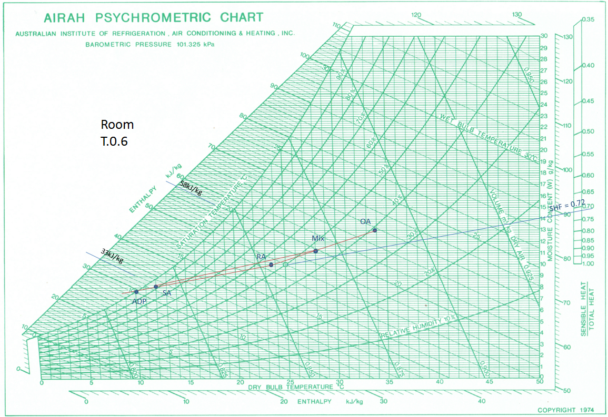

*Figure 5: Psychrometric Chart for Room T.0.6*

### 5.2.2 Room MM.0.3

The chart for MM.0.3 is performed in the same way as in T.0.6. Data for MM.0.3 is listed below.

OA: 33.8°C DB/22.9°C WB

RA: 23.5°C DB/55%RH

QS = 48454W

QL = 16709 W

Supply air mass flow:

Outside air mass flow:

The cooling coil efficiency:

Same as T.0.6, no reheat is needed.

The cooling coil load:

The psychrometric chart is shown below.

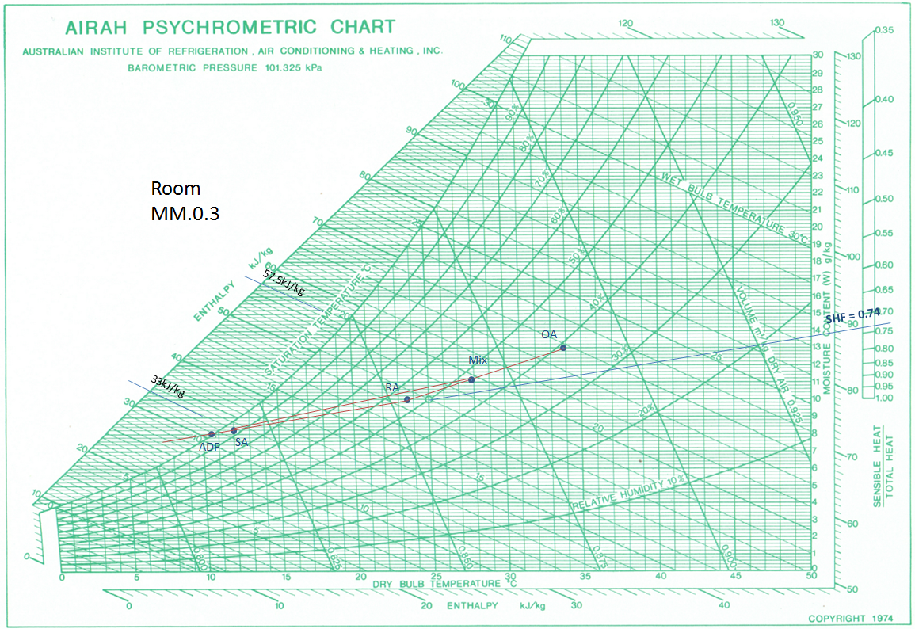

*Figure 6: Psychrometric Chart for Room MM.0.3*

# 6. CAMEL simulation

The CAMEL simulation is carried out in this section. Input data are demonstrated in section 6.1, and the simulation report is pasted in appendix A.

## 6.1 Simulation Process

The outdoor design condition is defined as following figure.

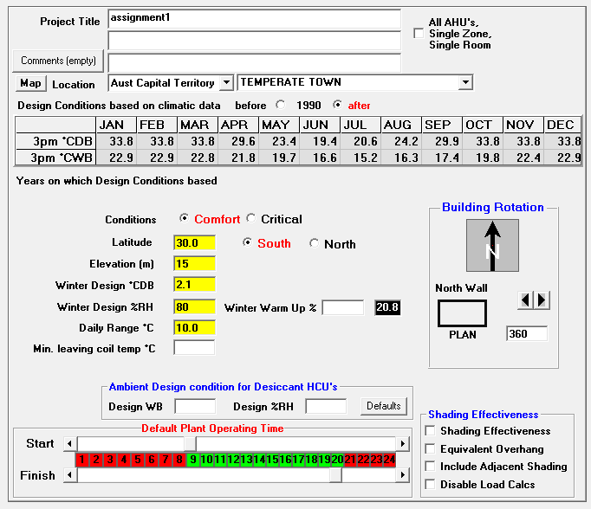

*Figure 7: Project Title & Outdoor Design Conditions*

The windows are defined as:

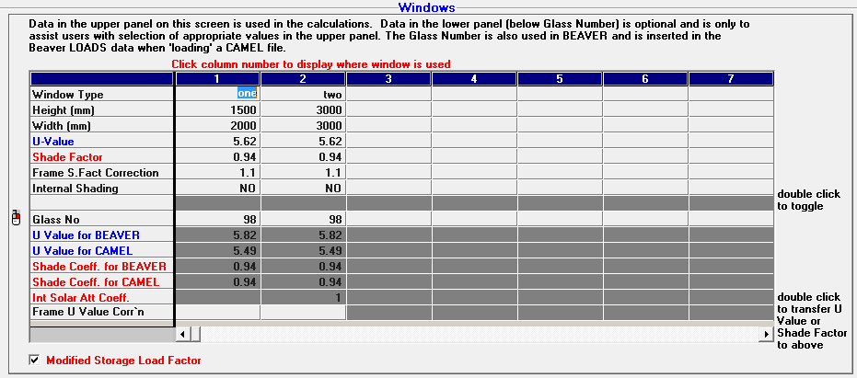

*Figure 8: Window Properties*

Walls properties are inserted.

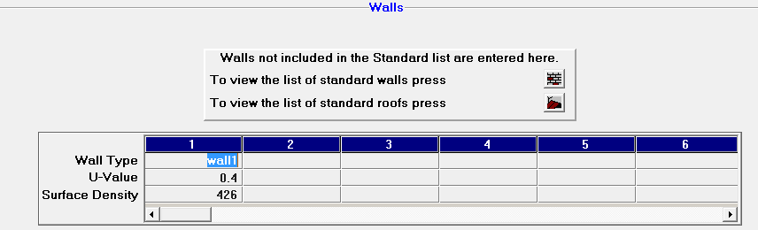

*Figure 9: Wall Properties*

Indoor design conditions are inserted.

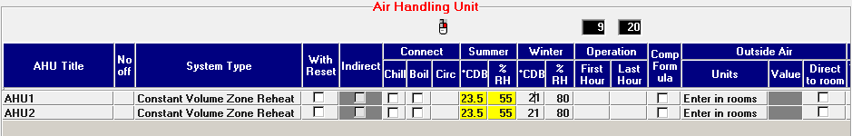

*Figure 10: Room Air Design Point*

Supply air conditions:

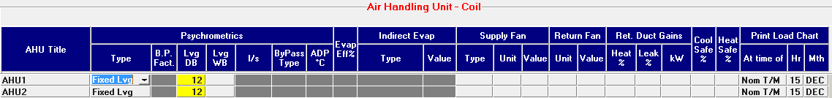

*Figure 11: AHU Coil Properties*

Room properties:

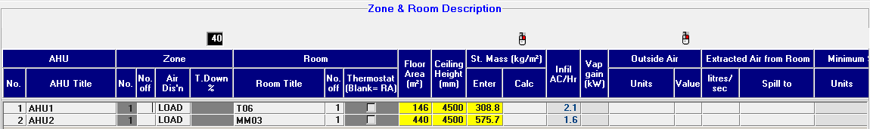

*Figure 12: Room Description*

External walls’ and windows’ properties:

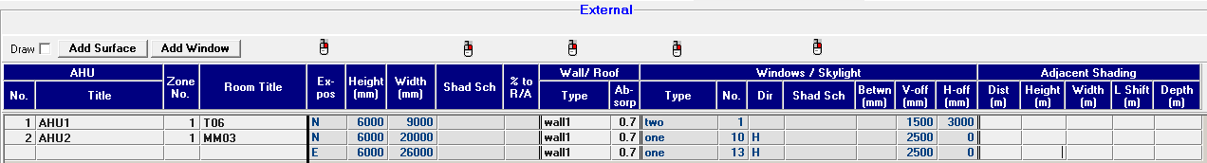

*Figure 13: External Properties*

Internal loads

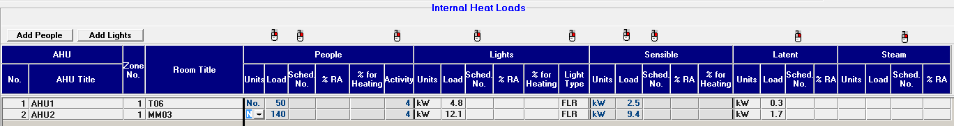

*Figure 14: Internal Loads*

## 6.2 CAMEL Results and Comparing

The heat load is summarized below in the table. The full report is shown in appendix A.

As seen from the table, the difference between CAMEL simulation and hand calculation is acceptable. The difference between each division is minimal. The highest difference is seen in radiation and people heat load, which may be caused by different choice of solar gain and diversity factor.

For room T.0.6, the difference in sensible load is:

The difference of latent load is:

For room MM.0.3, the difference in sensible load is:

The difference of latent load is:

Other reasons for the differences are that:

1. The assumptions made in hand calculation are different from those settings in CAMEL.
2. CAMEL is based on hourly data. Part of them is different from the choices made from DA09 tables.
3. Some numeric errors exist.

*Table 23: CAMEL Results and Comparing for T.0.6*

|  |  |  |  |  |  |
| --- | --- | --- | --- | --- | --- |
| **T.0.6** | | **CAMEL** | | **Hand Calculation** | |
| Sensible | Latent | Sensible | Latent |
| External | Wall | 94 | 0 | 140 | 0 |
| Radiation | 572 | 0 | 248 | 0 |
| Glass | 521 | 0 | 521 | 0 |
| Internal | People | 3600 | 2900 | 3240 | 2610 |
| Appliances | 2500 | 300 | 2542 | 300 |
| Lights | 4408 | 0 | 4803 | 0 |
| Infiltration | 4776 | 3541 | 4728 | 3328 |
| **Total** | | 16471 | 6741 | 16222 | 6238 |

*Table 24: CAMEL Results and Comparing for MM.0.3*

|  |  |  |  |  |  |
| --- | --- | --- | --- | --- | --- |
| **MM.0.3** | | **CAMEL** | | **Hand Calculation** | |
| Sensible | Latent |  |  |
| External | Wall | 626 | 0 | 739 | 0 |
| Radiation | 834 | 0 | 1219 | 0 |
| Glass | 3995 | 0 | 3994 | 0 |
| Internal | People | 10080 | 8120 | 9072 | 7308 |
| Appliances | 9400 | 1700 | 9390 | 1680 |
| Lights | 10602 | 0 | 12144 | 0 |
| Infiltration | 10967 | 8130 | 11970 | 7721 |
| **Total** | | 46264 | 17950 | 48528 | 16709 |

For the heating load in winter, CAMEL only gives out the sensible load, which is shown below. The latent load is unable to be compared.

The comparing table is shown below. The difference between sensible heat load for T.0.6 is:

Difference for MM.0.3 is:

*Table 25: Heating Load in Winter*

|  |  |  |  |  |
| --- | --- | --- | --- | --- |
| Load Type | camel | | hand calculation | |
| T06 | MM03 | T06 | MM03 |
| sensible | 10296 | 30850 | 9670 | 29019 |
| latent | / | / | 9383 | 23164 |

# 7. Conclusion

Throughout the calculation and simulation of the heat load of shop T.0.6 and MM.0.3, a comprehensive understanding of their conditions is gained. The design conditions are listed and explained in chapter 2. Wall specifications and external loads were carried out in chapter 3. Internal load calculation was performed in chapter 4. The overall loads are summarized and verified by CAMEL simulation in chapter 5 and chapter 6.

Based on the result, an efficient HVAC system is able to be designed in the following procedure.

For room T.0.6, the sensible load is 16.2 kW, the latent load is 6.2kW in summer, the cooling coil load is 34.5 kW.

For room MM.0.3, the sensible load is 48.5 kW, while the latent load is 16.7 kW in summer. Its cooling coil load is 101.2 kW.

Some optimization could be performed, such as taking use of more energy efficient appliances, replacing lights with more efficient LED and so on.

# References

[1] F. (AIRAH) Wickham, Ed., AIRAH DA09: Air Conditioning Load Estimation, Hill Inc, 1994. 3rd editio. McGraw-

[2] NCC 2016, Section J –Energy Efficiency.

[3] AS 1684.3 Residential Timber Frame Construction, 3rd ed. 2010.

# Appendix A

**ACADS BSG Program**

**CAMEL**

**Version Number 5.11.1**

**ACADS BSG advises that the program CAMEL is intended to be used only**

**by persons who are proficient in its use and application and that these**

**results should be verified independently. The results must not be used**

**without acceptance of the ACADS-BSG's License Agreement for this program.**

**AHU 1 AHU1**

Type ~ CV Zone Reheat without Reset No. Off ~ 1

Connected to ~ Chiller No Boiler No

Floor Area ~ 146 m2 Volume ~ 657.0 m3 Average Ceiling Height ~ 4500. mm

**AHU COOLING LOAD SUMMARY**

DESIGN COOLING LOAD IS 24.7 kW AT 3PM MAR

DESIGN COOLING LOAD IS AT PEAK AHU GTH

AHU OPERATING HOURS 9AM TO 8PM. CALCS BASED ON 16 HOURS OPERATION FROM 6AM

**CDB CWB g/kg %RH**

GTSH 18.2 kW AVERAGE ROOM AIR 23.5 17.4 9.93 55.0

GTLH 6.57 kW AHU O/A 33.8 22.8 12.89

AHU SH FACT 0.73

SUPPLY AIR 1306 l/s COIL DEW POINT 10.8 8.06

AHU O/A 0 l/s COIL LEAVING AIR 12.0 (N) 11.5 8.24

DEHUMID AIR 1306 l/s COIL ENTERING AIR 23.5 17.4 9.93

AIR ch/hr 7.2 RETURN AIR 23.5 17.4 9.93

l/s/m2 8.9 AVERAGE ROOM ENT. 12.0 11.5 8.24

l/s/kW 52.8 BYPASS FACTOR 0.09

W/m2 169 MIX R/A AND O/A 23.5 17.4 9.93

NOTE : (N) MEANS NOMINATED VALUE USED

**AHU COOLING LOAD CHART AT NOMINATED TIME 3PM DEC**

AHU OPERATING HOURS 9AM TO 8PM. CALCS BASED ON 16 HOURS OPERATION FROM 6AM

**ACCUMULATED ZONE/ROOM ADJUSTED HEAT**

ADJUSTED ROOM SENSIBLE = 16471

SUM OF ZONE REHEAT = 1701

ADJUSTED ROOM LATENT = 6741

________________

ADJUSTED TOTAL HEAT = 24913

**COOLING GRAND TOTAL HEAT = 24913**

COOLING GRAND TOTAL SENSIBLE HEAT = 18172

COOLING GRAND TOTAL LATENT HEAT = 6741

**ZONE REHEAT**

NO. kW

________

1 1.70

________

**AHU 2 AHU2**

Type ~ CV Zone Reheat without Reset No. Off ~ 1

Connected to ~ Chiller No Boiler No

Floor Area ~ 440 m2 Volume ~ 1980.0 m3 Average Ceiling Height ~ 4500. mm

**AHU COOLING LOAD SUMMARY**

DESIGN COOLING LOAD IS 75.7 kW AT 4PM MAR

DESIGN COOLING LOAD IS AT PEAK AHU GTH

AHU OPERATING HOURS 9AM TO 8PM. CALCS BASED ON 16 HOURS OPERATION FROM 6AM

**CDB CWB g/kg %RH**

GTSH 58.2 kW AVERAGE ROOM AIR 23.5 17.4 9.93 55.0

GTLH 17.6 kW AHU O/A 32.8 22.5 12.89

AHU SH FACT 0.77

SUPPLY AIR 4180 l/s COIL DEW POINT 11.5 8.47

AHU O/A 0 l/s COIL LEAVING AIR 12.0 (N) 11.8 8.52

DEHUMID AIR 4180 l/s COIL ENTERING AIR 23.5 17.4 9.93

AIR ch/hr 7.6 RETURN AIR 23.5 17.4 9.93

l/s/m2 9.5 AVERAGE ROOM ENT. 12.0 11.8 8.52

l/s/kW 55.2 BYPASS FACTOR 0.04

W/m2 172 MIX R/A AND O/A 23.5 17.4 9.93

NOTE : (N) MEANS NOMINATED VALUE USED

**AHU COOLING LOAD CHART AT NOMINATED TIME 3PM DEC**

AHU OPERATING HOURS 9AM TO 8PM. CALCS BASED ON 16 HOURS OPERATION FROM 6AM

**ACCUMULATED ZONE/ROOM ADJUSTED HEAT**

ADJUSTED ROOM SENSIBLE = 53805

SUM OF ZONE REHEAT = 4365

ADJUSTED ROOM LATENT = 17950

________________

ADJUSTED TOTAL HEAT = 76120

**COOLING GRAND TOTAL HEAT = 76120**

COOLING GRAND TOTAL SENSIBLE HEAT = 58170

COOLING GRAND TOTAL LATENT HEAT = 17950

**ZONE REHEAT**

NO. kW

________

1 4.36

________

**AHU 1 AHU1, Zone 1, Rm 1 T06**

**ROOM COOLING LOAD CHART AT NOMINATED TIME 3PM DEC**

(SUN POSITION ~ ALTITUDE = 49.3 AZIMUTH =268.1)

AHU OPERATING HOURS 9AM TO 8PM. CALCS BASED ON 16 HOURS OPERATION FROM 6AM

SOLAR GAIN GLASS ( 309 kg/m2. Modified storage load factors used)

**FRAME**

**No SUN EXPOSE AREA GAIN S.FAC DEW STOR SHADE ROOM WATTS**

_______________________________________________________________________________

#1 OFF 0.0 9.00 70 1.10 1.02 .857 0.94 100% = 572

SOLAR AND TRANSMISSION GAINS WALLS AND ROOFS (Using light wt roof data)

**No SUN EXPOSE S.DENS ABS AREA T-DIFF UVALUE ROOM**

_______________________________________________________________________________

#1 OFF 0.0 (426 0.70) 45.00 5.2 0.40 100% = 94

TRANSMISSION GAIN EXCEPT WALLS AND ROOFS

**No ITEM AREA T-DIFF UVALUE ROOM**

_______________________________________________________________________________

#1 GLASS 9.00 10.3 5.62 100% = 521

INFILTRATION 383. 10.3 1.21 = 4776

INTERNAL HEAT GAIN

PEOPLE (ACTIV = 4) 50.0 72. 100% = 3600

LIGHTS (FLR 309 kg/m2) 4800 0.92 100% = 4408

APPLIANCES 2.5 1000. 100% = 2500

__________________

**ROOM SENSIBLE HEAT = 16471**

________________

**ADJUSTED ROOM SENSIBLE HEAT = 16471**

LATENT HEAT GAIN

INFILTRATION 383 3.1 2.97 = 3541

PEOPLE (ACTIV = 4) 50.0 58. 100% = 2900

APPLIANCES 0.3 1000. 100% = 300

________________

**ROOM LATENT HEAT = 6741**

________________

**ADJUSTED ROOM LATENT HEAT = 6741**

**AHU 1 AHU1, Zone 1, Rm 1 T06**

**ROOM HEATING LOAD CHART**

**No EXPOSE AREA T-DIFF UVALUE WATTS**

SENSIBLE

______________________________________________________________________________

WALLS AND ROOFS

#1 0.0 45.0 20.3 0.40 = 367

WINDOWS

#1 0.0 9.0 20.3 6.10 = 1114

INFILTRATION 383. l/s 20.3 1.21 = 9414

____________________________________

**ROOM SENSIBLE HEAT = 10896**

**AHU 2 AHU2, Zone 1, Rm 1 MM03**

**ROOM COOLING LOAD CHART AT NOMINATED TIME 3PM DEC**

(SUN POSITION ~ ALTITUDE = 49.3 AZIMUTH =268.1)

AHU OPERATING HOURS 9AM TO 8PM. CALCS BASED ON 16 HOURS OPERATION FROM 6AM

SOLAR GAIN GLASS ( 576 kg/m2. Modified storage load factors used)

**FRAME**

**No SUN EXPOSE AREA GAIN S.FAC DEW STOR SHADE ROOM WATTS**

_______________________________________________________________________________

#1 OFF 0.0 30.00 70 1.10 1.02 .762 0.94 100% = 1696

#2 ON 270.0 39.00 70 1.10 1.02 .289 0.94 100% = 834

SOLAR AND TRANSMISSION GAINS WALLS AND ROOFS (Using light wt roof data)

**No SUN EXPOSE S.DENS ABS AREA T-DIFF UVALUE ROOM**

_______________________________________________________________________________

#1 OFF 0.0 (426 0.70) 90.00 5.2 0.40 100% = 188

#2 ON 270.0 (426 0.70) 117.00 9.4 0.40 100% = 438

TRANSMISSION GAIN EXCEPT WALLS AND ROOFS

**No ITEM AREA T-DIFF UVALUE ROOM**

_______________________________________________________________________________

#1 GLASS 30.00 10.3 5.62 100% = 1737

#2 GLASS 39.00 10.3 5.62 100% = 2258

INFILTRATION 880. 10.3 1.21 = 10967

INTERNAL HEAT GAIN

PEOPLE (ACTIV = 4) 140.0 72. 100% = 10080

LIGHTS (FLR 576 kg/m2) 12100 0.88 100% = 10602

APPLIANCES 9.4 1000. 100% = 9400

__________________

**ROOM SENSIBLE HEAT** = 46264

________________

**ADJUSTED ROOM SENSIBLE HEAT =** 46264

LATENT HEAT GAIN

INFILTRATION 880 3.1 2.97 = 8130

PEOPLE (ACTIV = 4) 140.0 58. 100% = 8120

APPLIANCES 1.7 1000. 100% = 1700

________________

**ROOM LATENT HEAT = 17250**

________________

**ADJUSTED ROOM LATENT HEAT = 17250**

**AHU 2 AHU2, Zone 1, Rm 1 MM03**

**ROOM HEATING LOAD CHART**

**No EXPOSE AREA T-DIFF UVALUE WATTS**

SENSIBLE

______________________________________________________________________________

WALLS AND ROOFS

#1 0.0 90.0 20.3 0.40 = 735

#2 270.0 117.0 20.3 0.40 = 955

WINDOWS

#1 0.0 30.0 20.3 6.10 = 3715

#2 270.0 39.0 20.3 6.10 = 4829

INFILTRATION 880. l/s 20.3 1.21 = 21615

____________________________________

**ROOM SENSIBLE HEAT = 30850**